let - for block scoped variables
const - for constants whose values can't be changed throughout the program
var - We used to have var in our codes before ES6 for globally scoped variables

Differences between var and let:
- var is globally scoped and value can be changed anywhere and if changed inside a block it will also behave the same outside the block which will cause errors and let handles this problem.
- variables created with var can be redefined a different value in the code again and again causing problems for bigger applications and let handles it.

Primitive Data Types
Null Number
String Symbol
Boolean Big int Undefined
Objects
Non primitive data type to create key-value pairs.

Operators
Difference between == and === is that == only compares the value but === compares value and type both. so It is better to use === in your web applications to avoid errors in the future.

Conditional Expressions
We have different conditional expressions available like if, if else, if else if. But it is advised to use ternary operator for conditional rendering in JS.

Loops
For Loop
While Loop
Do While Loop

Functions
Functions are defined to reuse the logic again and again and syntax is -
- function function_name (parameters){ .... } (Old way)
- const function_name = ()=>{ ... } (New Way) (Using Array Functions)

Strings
Can be made using single quotes or double quotes but cannot be made using both at the same time.
Examples -
"adffd" ✅, 'ddsd' ✅, "wsds' ❌
Can also be written using backticks and main advantage is we can use variables in it.
Escape Sequences
For using inverted comma's inside strings.
Example - 'comma\'s' - Output - comma's
and another examples are '\n' , '\t' , etc.

String Methods
- length - Property to find string length
- toUpperCase() - Function to change string to upper case.
- toLowerCase() - Function to change string to lower case.
- slice(start_index , end_index) - Function to access the indices of the string from start_index to end_index - 1
- replace (prev_string , curr_string) - Function to replace previous string to current string.
- concat ( string1 , string2 ) - Function to add two strings.
- trim ( string ) - Function to remove Extras/paces.

Arrays
Arrays are a data structure present in JS. But mainly array methods are important as in context of placements.
Methods:
- toString() => Converts any array into a string. (creates new array)
- join("separator") => Join array elements using that separator. (creates new array)
- pop() => Deletes element from array. (changes original array)
- push() => Adds a new element in an array. (changes original array)
- shift() => Removes first element and returns it. (changes original array)
- unshift() => Adds element in the beginning of an array and return array length. (changes original array)
- concat() => Adds more arrays into another.
- sort() => sorts the array in ascending order.
- splice() => used to add new elements in the array.
- reverse() => Reverse the elements of array.

Loops through Arrays:
- for Each loop => It accepts three parameters (value, index, array) and executes like a for loop.
- map() => It is same as for Each, accepts the same three parameters (value, index, array).
- filter() => Filters an array with values that passes a test, creates a new array.
- reduce() => Reduces an array to a single value.
- for...of => for...of loop can be used to get the values from an array.
- for...in => for...in loop can be used to get the keys from an array.

Java script in the Browser
Console Object Methods
- assert() => used to assert a condition.
- clear() => clears the console.
- log() => outputs a message into console
- table() => displays tabular data.
- warn() => used for warnings.
- error() => used for errors.
- info() => used for special information.

Window Object, DOM, BOM
Document Object Model (DOM)
DOM represents the page content as HTML.
document .body = Page body as object.

Browser Object Model (BOM)
It represents additional objects provided by the browser like location.

DOM MANIPULATION
DOM tree refers to the HTML Page where all nodes are objects. There are 3 main types of nodes in DOM tree:

- Text Nodes
- Comment Nodes
- Element Nodes

Note: HTML has a utility for auto correction of tags like if you start a tag p and close this with another tag, browser takes care of it and closes your tag.
Note: If the document .body is accessed before body tag it will return null.

Children of Element
Direct as well as nested elements of an element are called its children.
For Ex - head and body are children of html tag

Child Nodes => Direct Childs of a element
Descendant Nodes => All nested elements

firstChild => returns first child node of an element.
lastChild => returns last child node of an element.
childNodes => returns no of child nodes of an element.
hasChildNodes() => returns true if children nodes exist else false.

Note: childNodes look like an array but it is not an array but a collection which can be converted to an array using Array.from(collection).

Element Only Navigation
For this we use same methods but use element with it
For Ex - firstElementChild , lastElementChild , etc.

Table Navigation
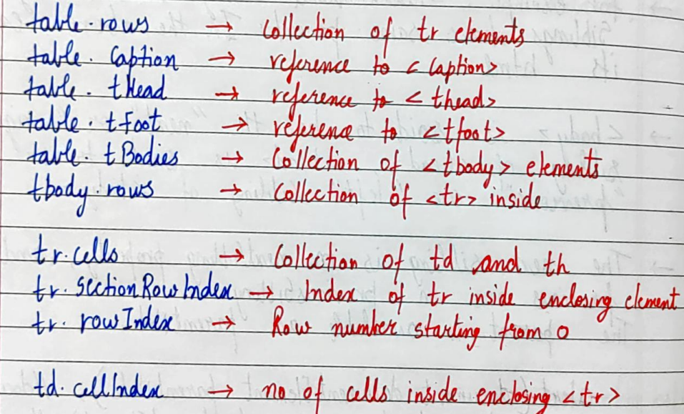

Searching the DOM
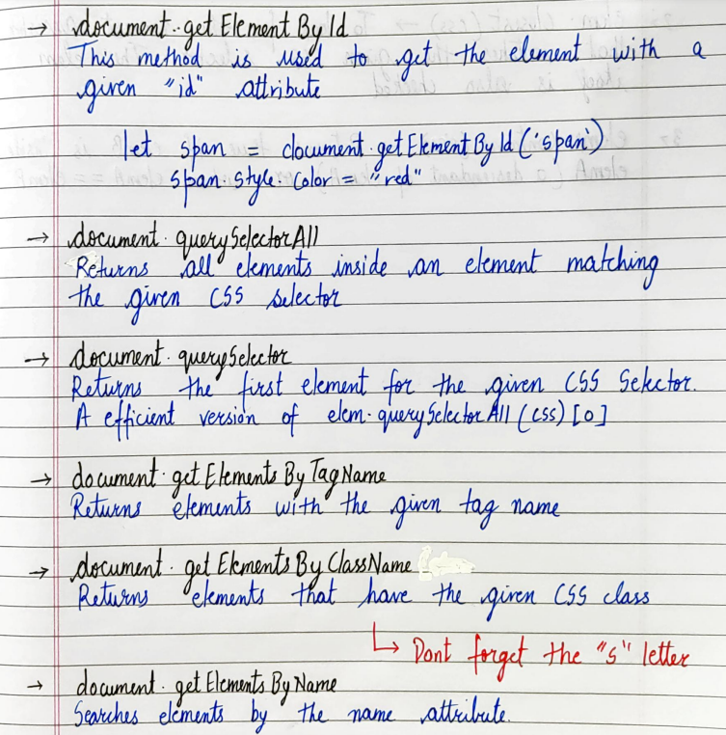

Matches, Closest and Contains
Matches => To check if any element matches the given CSS selector.
Closest => To look for the nearest ancestor that matches the given CSS selector.
Contains => Returns true if element B is inside element A.

set Timeout() and set Interval()
setTimeout( ) => used to run a function after a provided period of time and it returns a timerId.
setInterval( ) => used to run a function repeatedly in an interval of time.

Callbacks

